Unit 4

What Is Economics, and Why Is It Important?

Economics is the study of how humans make decisions in the face of scarcity. These can be individual decisions, family decisions, business decisions or societal decisions. If you look around carefully, you will see that scarcity is a fact of life. Scarcity means that human wants for goods, services and resources exceed what is available. Resources, such as labor, tools, land, and raw materials are necessary to produce the goods and services we want but they exist in limited supply. Of course, the ultimate scarce resource is time- everyone, rich or poor, has just 24 expendable hours in the day to earn income to acquire goods and services, for leisure time, or for sleep. At any point in time, there is only a finite amount of resources available.

Think about it this way: In 2015 the labor force in the United States contained over 158 million workers, according to the U.S. Bureau of Labor Statistics. The total land area was 3,794,101 square miles. While these are certainly large numbers, they are not infinite. Because these resources are limited, so are the numbers of goods and services we produce with them. Combine this with the fact that human wants seem to be virtually infinite, and you can see why scarcity is a problem.

Microeconomics and Macroeconomics
Economics acknowledges that production of useful goods and services can create problems of environmental pollution. It explores the question of how investing in education helps to develop workers’ skills. It probes questions like how to tell when big businesses or big labor unions are operating in a way that benefits society as a whole and when they are operating in a way that benefits their owners or members at the expense of others. It looks at how government spending, taxes, and regulations affect decisions about production and consumption.
It should be clear by now that economics covers considerable ground. We can divide that ground into two parts: Microeconomics focuses on the actions of individual agents within the economy, like households, workers, and businesses. Macroeconomics looks at the economy as a whole. It focuses on broad issues such as growth of production, the number of unemployed people, the inflationary increase in prices, government deficits, and levels of exports and imports. Microeconomics and macroeconomics are not separate subjects, but rather complementary perspectives on the overall subject of the economy.

To understand why both microeconomic and macroeconomic perspectives are useful, consider the problem of studying a biological ecosystem like a lake. One person who sets out to study the lake might focus on specific topics: certain kinds of algae or plant life; the characteristics of particular fish or snails; or the trees surrounding the lake. Another person might take an overall view and instead consider the lake's ecosystem from top to bottom; what eats what, how the system stays in a rough balance, and what environmental stresses affect this balance. Both approaches are useful, and both examine the same lake, but the viewpoints are different. In a similar way, both microeconomics and macroeconomics study the same economy, but each has a different viewpoint.
Whether you are scrutinizing lakes or economics, the micro and the macro insights should blend with each other. In studying a lake, the micro insights about particular plants and animals help to understand the overall food chain, while the macro insights about the overall food chain help to explain the environment in which individual plants and animals live.

In economics, the micro decisions of individual businesses are influenced by whether the macroeconomy is healthy. For example, firms will be more likely to hire workers if the overall economy is growing. In turn, macroeconomy's performance ultimately depends on the microeconomic decisions that individual households and businesses make.

Microeconomics

What determines how households and individuals spend their budgets? What combination of goods and services will best fit their needs and wants, given the budget they have to spend? How do people decide whether to work, and if so, whether to work full time or part time? How do people decide how much to save for the future, or whether they should borrow to spend beyond their current means?

What determines the products, and how many of each, a firm will produce and sell? What determines the prices a firm will charge? What determines how a firm will produce its products? What determines how many workers it will hire? How will a firm finance its business? When will a firm decide to expand, downsize, or even close? In the microeconomics part of this book, we will learn about the theory of consumer behavior, the theory of the firm, how markets for labor and other resources work, and how markets sometimes fail to work properly.

Macroeconomics

What determines the level of economic activity in a society? In other words, what determines how many goods and services a nation actually produces? What determines how many jobs are available in an economy? What determines a nation’s standard of living? What causes the economy to speed up or slow down? What causes firms to hire more workers or to lay them off? Finally, what causes the economy to grow over the long term?

We can determine an economy's macroeconomic health by examining a number of goals: growth in the standard of living, low unemployment, and low inflation, to name the most important. How can we use government macroeconomic policy to pursue these goals? A nation's central bank conducts monetary policy, which involves policies that affect bank lending, interest rates, and financial capital markets. For the United States, this is the Federal Reserve. A nation's legislative body determines fiscal policy, which involves government spending and taxes. For the United States, this is the Congress and the executive branch, which originates the federal budget. These are the government's main tools. Americans tend to expect that government can fix whatever economic problems we encounter, but to what extent is that expectation realistic?

How Economists Use Theories and Models to Understand Economic Issues

John Maynard Keynes (1883–1946), one of the greatest economists of the twentieth century, pointed out that economics is not just a subject area but also a way of thinking. Keynes famously wrote in the introduction to a fellow economist’s book: “[Economics] is a method rather than a doctrine, an apparatus of the mind, a technique of thinking, which helps its possessor to draw correct conclusions.” In other words, economics teaches you how to think, not what to think.

Economists see the world through a different lens than anthropologists, biologists, classicists, or practitioners of any other discipline. They analyze issues and problems using economic theories that are based on particular assumptions about human behavior. These assumptions tend to be different than the assumptions an anthropologist or psychologist might use. A theory is a simplified representation of how two or more variables interact with each other. The purpose of a theory is to take a complex, real-world issue and simplify it down to its essentials. If done well, this enables the analyst to understand the issue and any problems around it. A good theory is simple enough to understand, while complex enough to capture the key features of the object or situation you are studying.

Sometimes economists use the term model instead of theory. Strictly speaking, a theory is a more abstract representation, while a model is a more applied or empirical representation. We use models to test theories, but for this course we will use the terms interchangeably.

For example, an architect who is planning a major office building will often build a physical model that sits on a tabletop to show how the entire city block will look after the new building is constructed. Companies often build models of their new products, which are more rough and unfinished than the final product, but can still demonstrate how the new product will work.

A good model to start with in economics is the circular flow diagram (Figure 1.6). It pictures the economy as consisting of two groups—households and firms—that interact in two markets: the goods and services market in which firms sell and households buy and the labor market in which households sell labor to business firms or other employees.

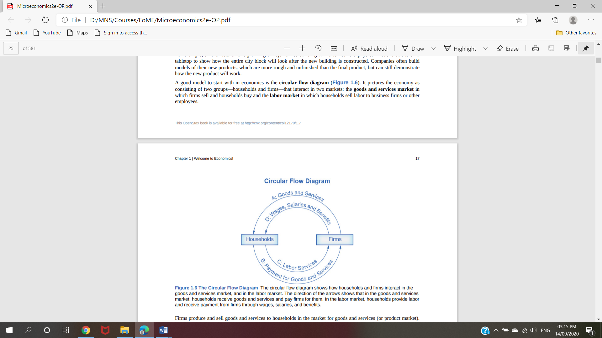

Figure 1.6 The Circular Flow Diagram The circular flow diagram shows how households and firms interact in the goods and services market, and in the labor market. The direction of the arrows shows that in the goods and services market, households receive goods and services and pay firms for them. In the labor market, households provide labor and receive payment from firms through wages, salaries, and benefits.

Firms produce and sell goods and services to households in the market for goods and services (or product market). Arrow “A” indicates this. Households pay for goods and services, which becomes the revenues to firms. Arrow “B” indicates this. Arrows A and B represent the two sides of the product market. Where do households obtain the income to buy goods and services? They provide the labor and other resources (e.g. land, capital, raw materials) firms need to produce goods and services in the market for inputs (or factors of production). Arrow “C” indicates this. In return, firms pay for the inputs (or resources) they use in the form of wages and other factor payments. Arrow “D” indicates this. Arrows “C” and “D” represent the two sides of the factor market.

Of course, in the real world, there are many different markets for goods and services and markets for many different types of labor. The circular flow diagram simplifies this to make the picture easier to grasp. In the diagram, firms produce goods and services, which they sell to households in return for revenues. The outer circle shows this, and represents the two sides of the product market (for example, the market for goods and services) in which households demand and firms supply. Households sell their labor as workers to firms in return for wages, salaries, and benefits. The inner circle shows this and represents the two sides of the labor market in which households supply and firms demand.

This version of the circular flow model is stripped down to the essentials, but it has enough features to explain how the product and labor markets work in the economy. We could easily add details to this basic model if we wanted to introduce more real-world elements, like financial markets, governments, and interactions with the rest of the globe (imports and exports).

Economists carry a set of theories in their heads like a carpenter carries around a toolkit. When they see an economic issue or problem, they go through the theories they know to see if they can find one that fits. Then they use the theory to derive insights about the issue or problem. Economists express theories as diagrams, graphs, or even as mathematical equations. (Do not worry. In this course, we will mostly use graphs.) Economists do not figure out the answer to the problem first and then draw the graph to illustrate. Rather, they use the graph of the theory to help them figure out the answer. Although at the introductory level, you can sometimes figure out the right answer without applying a model, if you keep studying economics, before too long you will run into issues and problems that you will need to graph to solve. We explain both micro and macroeconomics in terms of theories and models. The most well-known theories are probably those of supply and demand, but you will learn a number of others.

Demand and Supply at Work in Labor Markets

The law of demand applies in labor markets this way: A higher salary or wage—that is, a higher price in the labor market—leads to a decrease in the quantity of labor demanded by employers, while a lower salary or wage leads to an increase in the quantity of labor demanded. The law of supply functions in labor markets, too: A higher price for labor leads to a higher quantity of labor supplied; a lower price leads to a lower quantity supplied.

Equilibrium in the Labor Market In 2015, about 35,000 registered nurses worked in the Minneapolis-St. Paul-Bloomington, Minnesota-Wisconsin metropolitan area, according to the BLS. They worked for a variety of employers: hospitals, doctors’ offices, schools, health clinics, and nursing homes. Figure 4.2 illustrates how demand and supply determine equilibrium in this labor market. The demand and supply schedules in Table 4.1 list the quantity supplied and quantity demanded of nurses at different salaries.
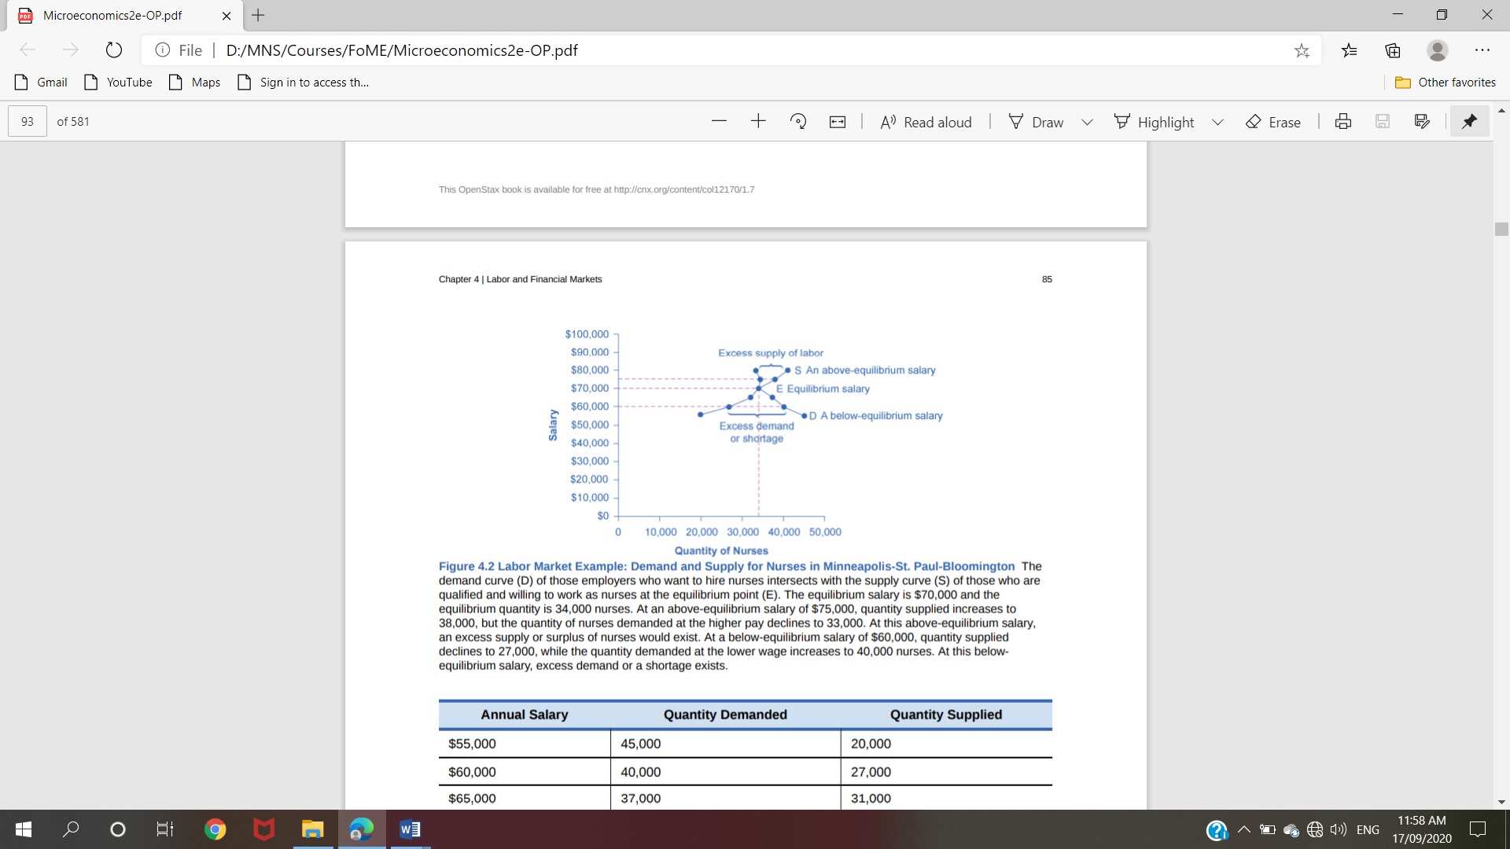

Figure 4.2 Labor Market Example: Demand and Supply for Nurses in Minneapolis-St. Paul-Bloomington The demand curve (D) of those employers who want to hire nurses intersects with the supply curve (S) of those who are qualified and willing to work as nurses at the equilibrium point (E). The equilibrium salary is $70,000 and the equilibrium quantity is 34,000 nurses. At an above-equilibrium salary of $75,000, quantity supplied increases to 38,000, but the quantity of nurses demanded at the higher pay declines to 33,000. At this above-equilibrium salary, an excess supply or surplus of nurses would exist. At a below-equilibrium salary of $60,000, quantity supplied declines to 27,000, while the quantity demanded at the lower wage increases to 40,000 nurses. At this belowequilibrium salary, excess demand or a shortage exists

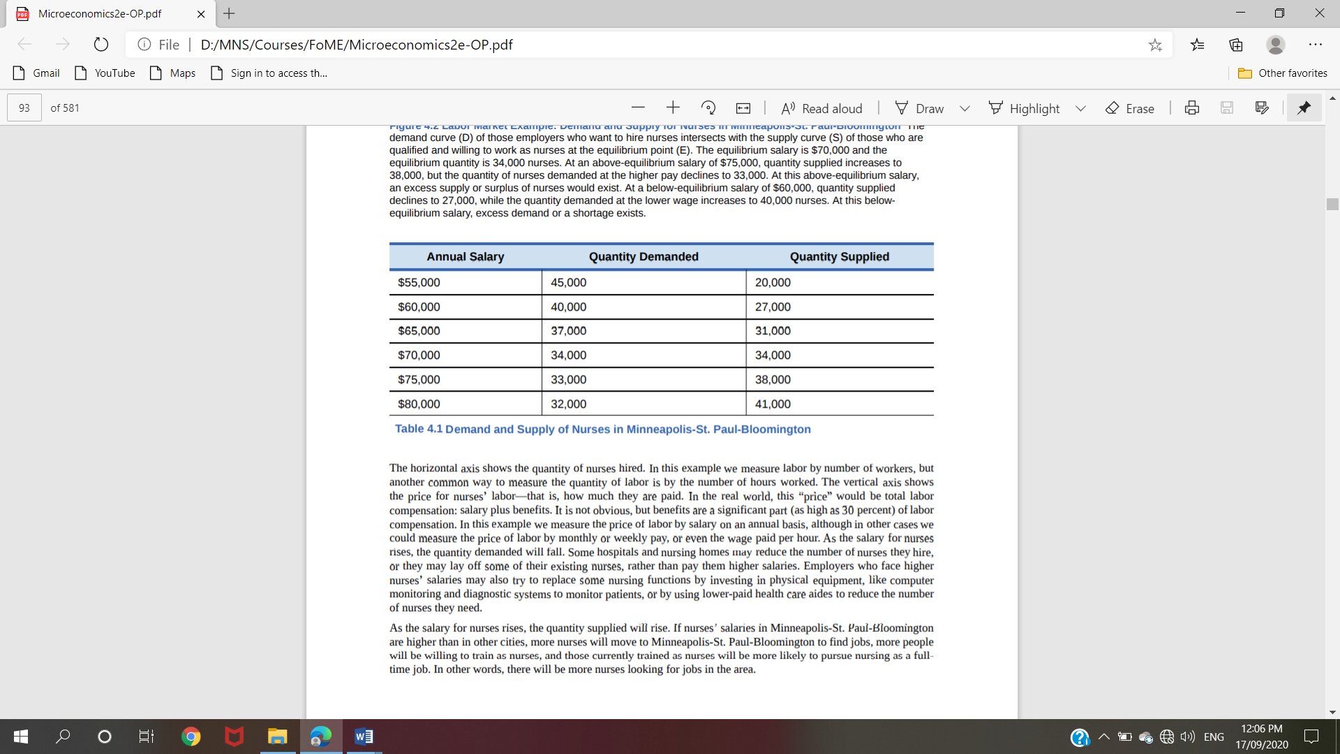
Table 4.1 Demand and Supply of Nurses in Minneapolis-St. Paul-Bloomington

The horizontal axis shows the quantity of nurses hired. In this example we measure labor by number of workers, but another common way to measure the quantity of labor is by the number of hours worked. The vertical axis shows the price for nurses’ labor—that is, how much they are paid. In the real world, this “price” would be total labor compensation: salary plus benefits. It is not obvious, but benefits are a significant part (as high as 30 percent) of labor compensation. In this example we measure the price of labor by salary on an annual basis, although in other cases we could measure the price of labor by monthly or weekly pay, or even the wage paid per hour. As the salary for nurses rises, the quantity demanded will fall. Some hospitals and nursing homes may reduce the number of nurses they hire, or they may lay off some of their existing nurses, rather than pay them higher salaries. Employers who face higher nurses’ salaries may also try to replace some nursing functions by investing in physical equipment, like computer monitoring and diagnostic systems to monitor patients, or by using lower-paid health care aides to reduce the number of nurses they need.

As the salary for nurses rises, the quantity supplied will rise. If nurses’ salaries in Minneapolis-St. Paul-Bloomington are higher than in other cities, more nurses will move to Minneapolis-St. Paul-Bloomington to find jobs, more people will be willing to train as nurses, and those currently trained as nurses will be more likely to pursue nursing as a fulltime job. In other words, there will be more nurses looking for jobs in the area.

At equilibrium, the quantity supplied and the quantity demanded are equal. Thus, every employer who wants to hire a nurse at this equilibrium wage can find a willing worker, and every nurse who wants to work at this equilibrium salary can find a job. In Figure 4.2, the supply curve (S) and demand curve (D) intersect at the equilibrium point (E). The equilibrium quantity of nurses in the Minneapolis-St. Paul-Bloomington area is 34,000, and the equilibrium salary is $70,000 per year. This example simplifies the nursing market by focusing on the “average” nurse. In reality, of course, the market for nurses actually comprises many smaller markets, like markets for nurses with varying degrees of experience and credentials. Many markets contain closely related products that differ in quality. For instance, even a simple product like gasoline comes in regular, premium, and super-premium, each with a different price. Even in such cases, discussing the average price of gasoline, like the average salary for nurses, can still be useful because it reflects what is happening in most of the submarkets. When the price of labor is not at the equilibrium, economic incentives tend to move salaries toward the equilibrium. For example, if salaries for nurses in Minneapolis-St. Paul-Bloomington were above the equilibrium at $75,000 per year, then 38,000 people want to work as nurses, but employers want to hire only 33,000 nurses. At that aboveequilibrium salary, excess supply or a surplus results. In a situation of excess supply in the labor market, with many applicants for every job opening, employers will have an incentive to offer lower wages than they otherwise would have. Nurses’ salary will move down toward equilibrium. In contrast, if the salary is below the equilibrium at, say, $60,000 per year, then a situation of excess demand or a shortage arises. In this case, employers encouraged by the relatively lower wage want to hire 40,000 nurses, but only 27,000 individuals want to work as nurses at that salary in Minneapolis-St. Paul-Bloomington. In response to the shortage, some employers will offer higher pay to attract the nurses. Other employers will have to match the higher pay to keep their own employees. The higher salaries will encourage more nurses to train or work in Minneapolis-St. Paul-Bloomington. Again, price and quantity in the labor market will move toward equilibrium.

Price Elasticity of Demand and Price Elasticity of Supply

Both the demand and supply curve show the relationship between price and the number of units demanded or supplied. Price elasticity is the ratio between the percentage change in the quantity demanded (Qd) or supplied (Qs) and the corresponding percent change in price. The price elasticity of demand is the percentage change in the quantity demanded of a good or service divided by the percentage change in the price. The price elasticity of supply is the percentage change in quantity supplied divided by the percentage change in price

We can usefully divide elasticities into three broad categories: elastic, inelastic, and unitary. An elastic demand or elastic supply is one in which the elasticity is greater than one, indicating a high responsiveness to changes in price. Elasticities that are less than one indicate low responsiveness to price changes and correspond to inelastic demand or inelastic supply. Unitary elasticities indicate proportional responsiveness of either demand or supply, as Table 5.1 summarizes.

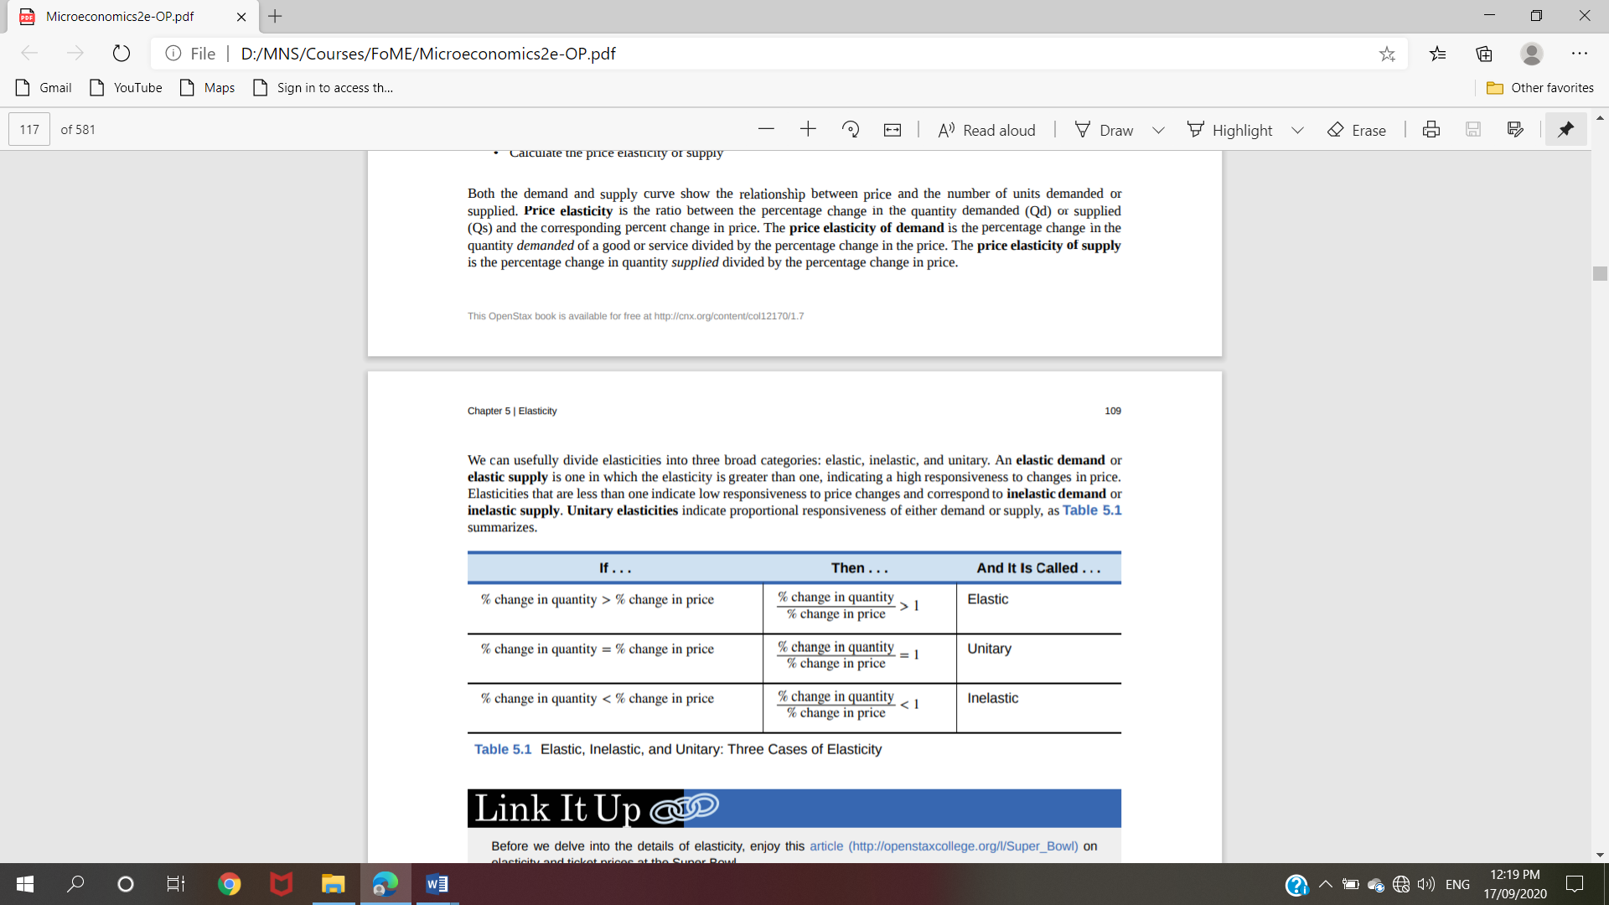

To calculate elasticity along a demand or supply curve economists use the average percent change in both quantity and price. This is called the Midpoint Method for Elasticity, and is represented in the following equations:
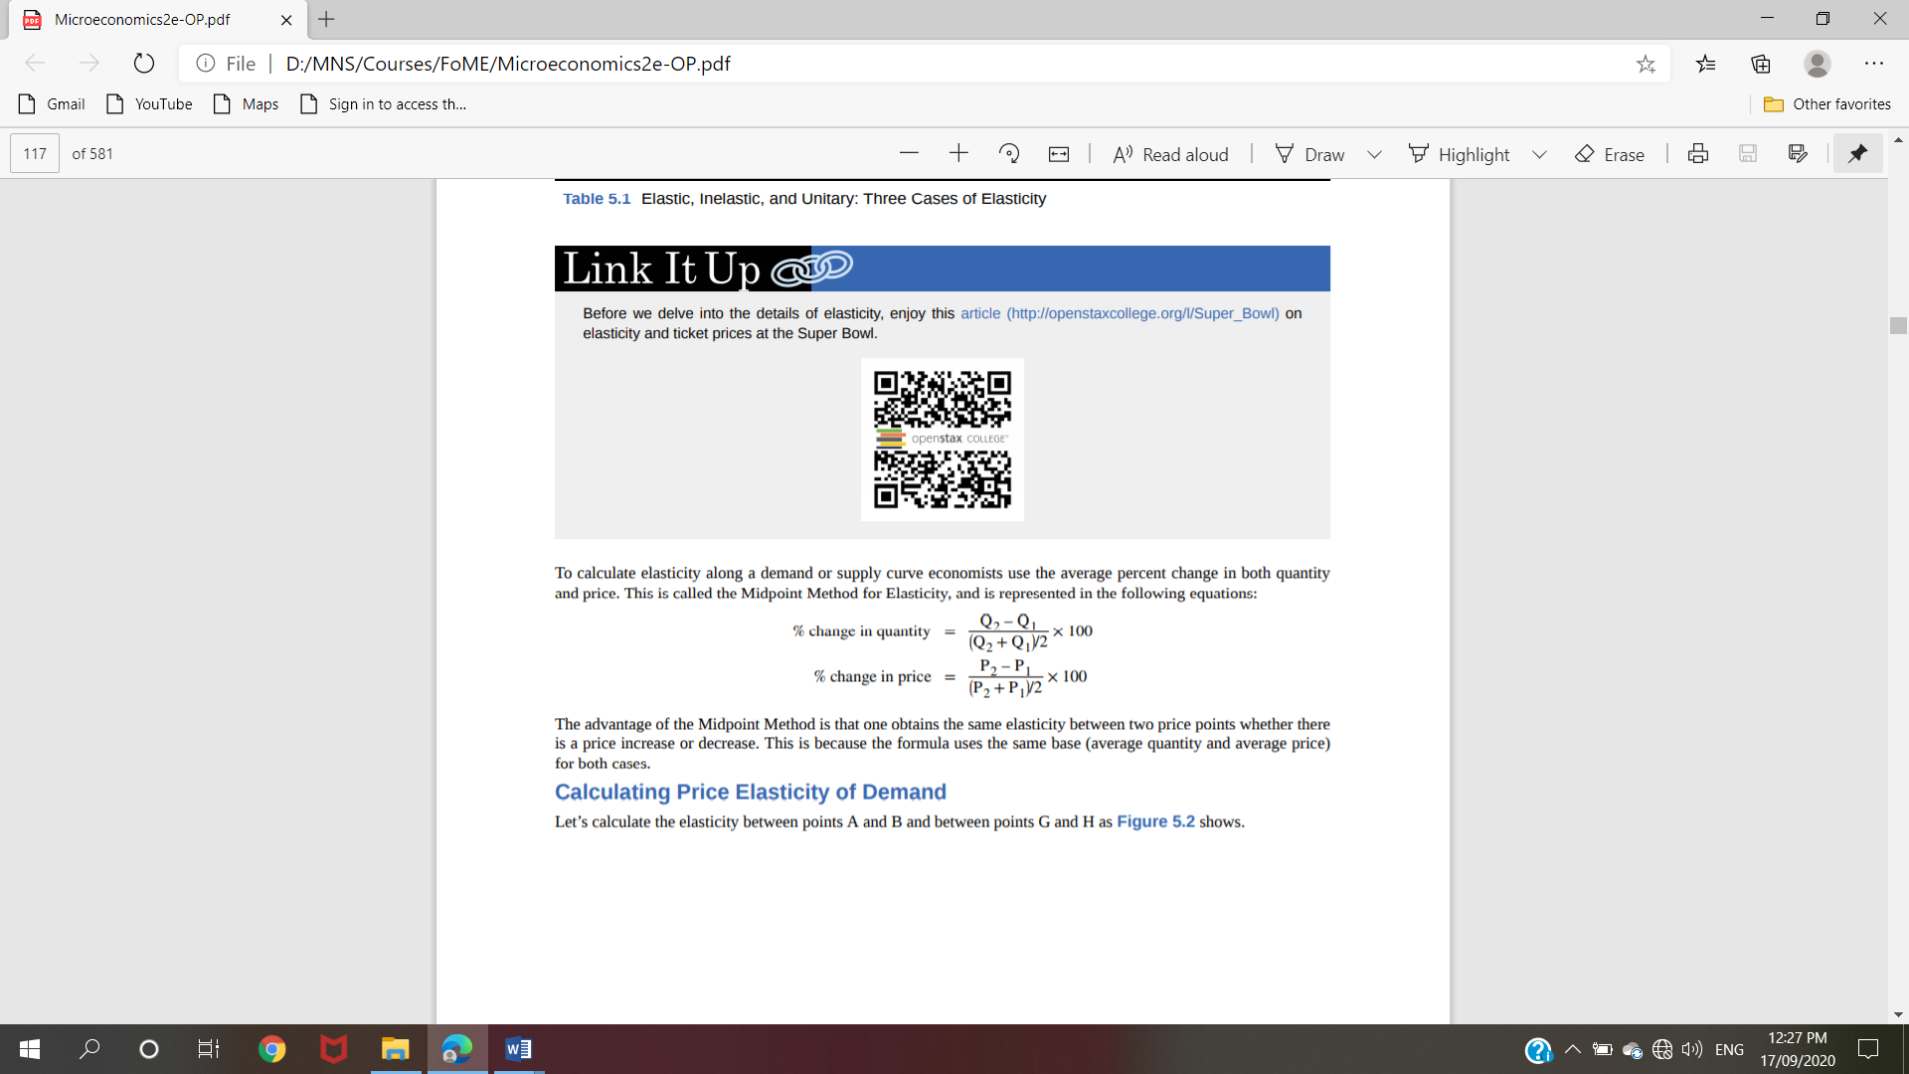
The advantage of the Midpoint Method is that one obtains the same elasticity between two price points whether there is a price increase or decrease. This is because the formula uses the same base (average quantity and average price) for both cases

Calculating Price Elasticity of Demand
Let’s calculate the elasticity between points A and B and between points G and H as Figure 5.2 shows
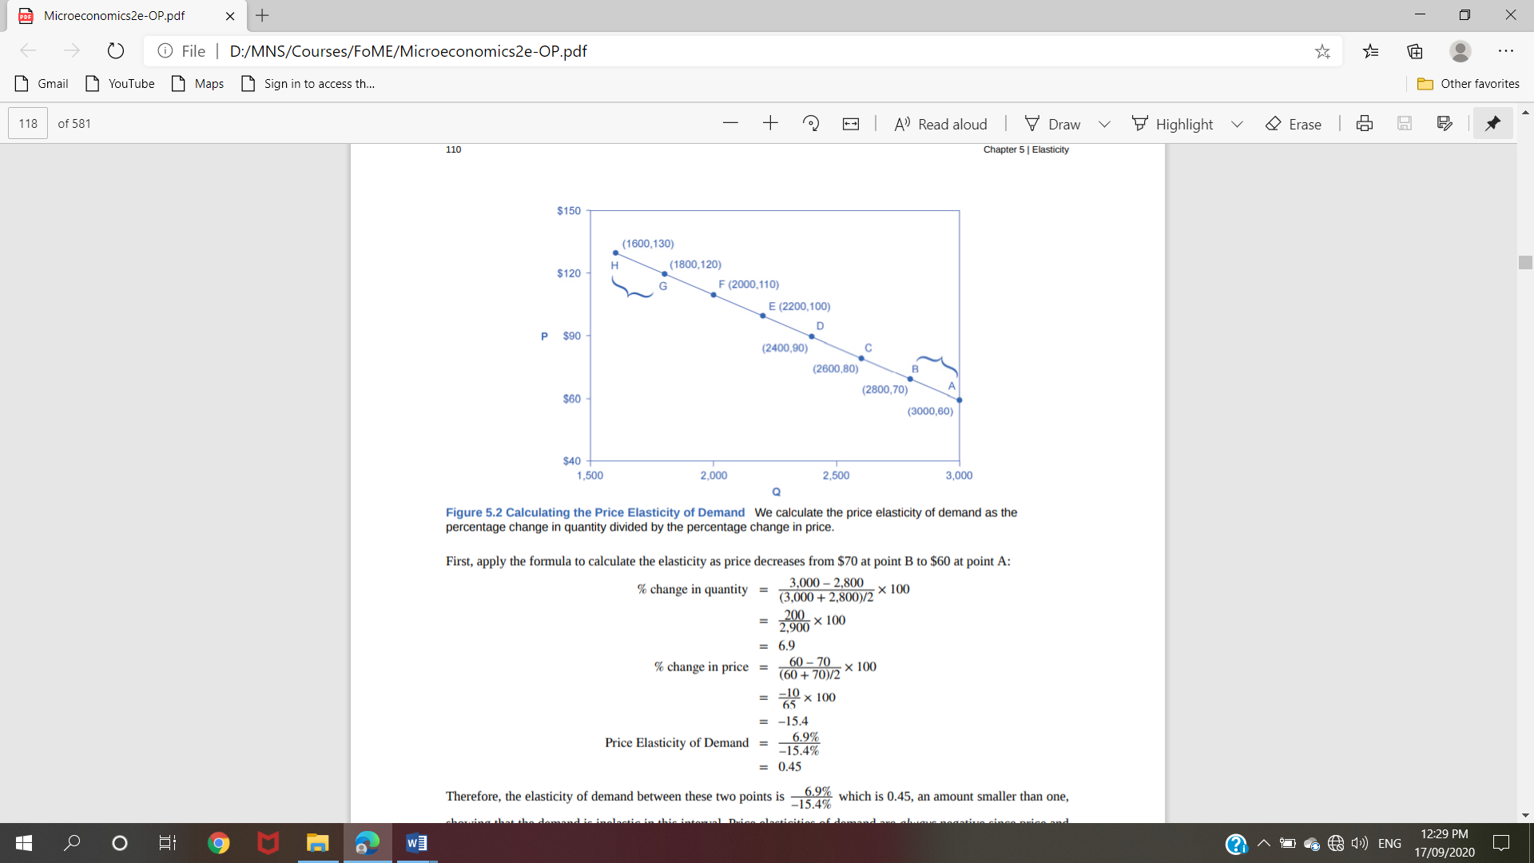

Therefore, the elasticity of demand between these two points is 6.9% –15.4% which is 0.45, an amount smaller than one, showing that the demand is inelastic in this interval. Price elasticities of demand are always negative since price and quantity demanded always move in opposite directions (on the demand curve). By convention, we always talk about elasticities as positive numbers. Mathematically, we take the absolute value of the result. We will ignore this detail from now on, while remembering to interpret elasticities as positive numbers

This means that, along the demand curve between point B and A, if the price changes by 1%, the quantity demanded will change by 0.45%. A change in the price will result in a smaller percentage change in the quantity demanded. For example, a 10% increase in the price will result in only a 4.5% decrease in quantity demanded. A 10% decrease in the price will result in only a 4.5% increase in the quantity demanded. Price elasticities of demand are negative numbers indicating that the demand curve is downward sloping, but we read them as absolute values. The following Work It Out feature will walk you through calculating the price elasticity of demand.

Calculating the Price Elasticity of Supply
Assume that an apartment rents for $650 per month and at that price the landlord rents 10,000 units are rented as Figure 5.3 shows. When the price increases to $700 per month, the landlord supplies 13,000 units into the market. By what percentage does apartment supply increase? What is the price sensitivity?
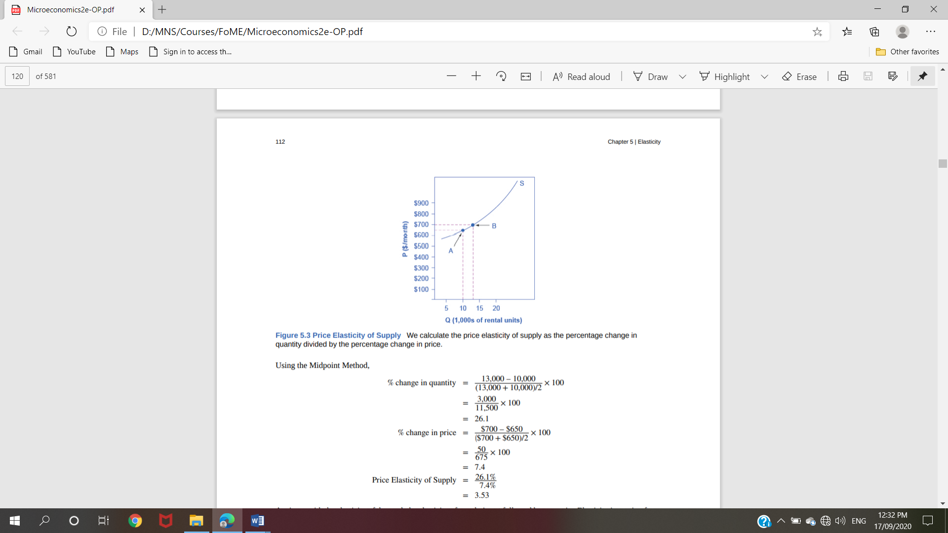

Again, as with the elasticity of demand, the elasticity of supply is not followed by any units. Elasticity is a ratio of one percentage change to another percentage change—nothing more—and we read it as an absolute value. In this case, a 1% rise in price causes an increase in quantity supplied of 3.5%. The greater than one elasticity of supply means that the percentage change in quantity supplied will be greater than a one percent price change. If you're starting to wonder if the concept of slope fits into this calculation, read the following Clear It Up box.

Monopolistic Competition

Monopolistic competition involves many firms competing against each other, but selling products that are distinctive in some way. Examples include stores that sell different styles of clothing; restaurants or grocery stores that sell a variety of food; and even products like golf balls or beer that may be at least somewhat similar but differ in public perception because of advertising and brand names. There are over 600,000 restaurants in the United States. When products are distinctive, each firm has a mini-monopoly on its particular style or flavor or brand name. However, firms producing such products must also compete with other styles and flavors and brand names. The term “monopolistic competition” captures this mixture of mini-monopoly and tough competition, and the following Clear It Up feature introduces its derivation

Differentiated Products
A firm can try to make its products different from those of its competitors in several ways: physical aspects of the product, location from which it sells the product, intangible aspects of the product, and perceptions of the product. We call products that are distinctive in one of these ways differentiated products.
Physical aspects of a product include all the phrases you hear in advertisements: unbreakable bottle, nonstick surface, freezer-to-microwave, non-shrink, extra spicy, newly redesigned for your comfort. A firm's location can also create a difference between producers. For example, a gas station located at a heavily traveled intersection can probably sell more gas, because more cars drive by that corner. A supplier to an automobile manufacturer may find that it is an advantage to locate close to the car factory.

Intangible aspects can differentiate a product, too. Some intangible aspects may be promises like a guarantee of satisfaction or money back, a reputation for high quality, services like free delivery, or offering a loan to purchase the product. Finally, product differentiation may occur in the minds of buyers. For example, many people could not tell the difference in taste between common varieties of ketchup or mayonnaise if they were blindfolded but, because of past habits and advertising, they have strong preferences for certain brands. Advertising can play a role in shaping these intangible preferences.

The concept of differentiated products is closely related to the degree of variety that is available. If everyone in the economy wore only blue jeans, ate only white bread, and drank only tap water, then the markets for clothing, food, and drink would be much closer to perfectly competitive. The variety of styles, flavors, locations, and characteristics creates product differentiation and monopolistic competition.

Perceived Demand for a Monopolistic Competitor
A monopolistically competitive firm perceives a demand for its goods that is an intermediate case between monopoly and competition. Figure 10.2 offers a reminder that the demand curve that a perfectly competitive firm faces is perfectly elastic or flat, because the perfectly competitive firm can sell any quantity it wishes at the prevailing market price. In contrast, the demand curve, as faced by a monopolist, is the market demand curve, since a monopolist is the only firm in the market, and hence is downward sloping.
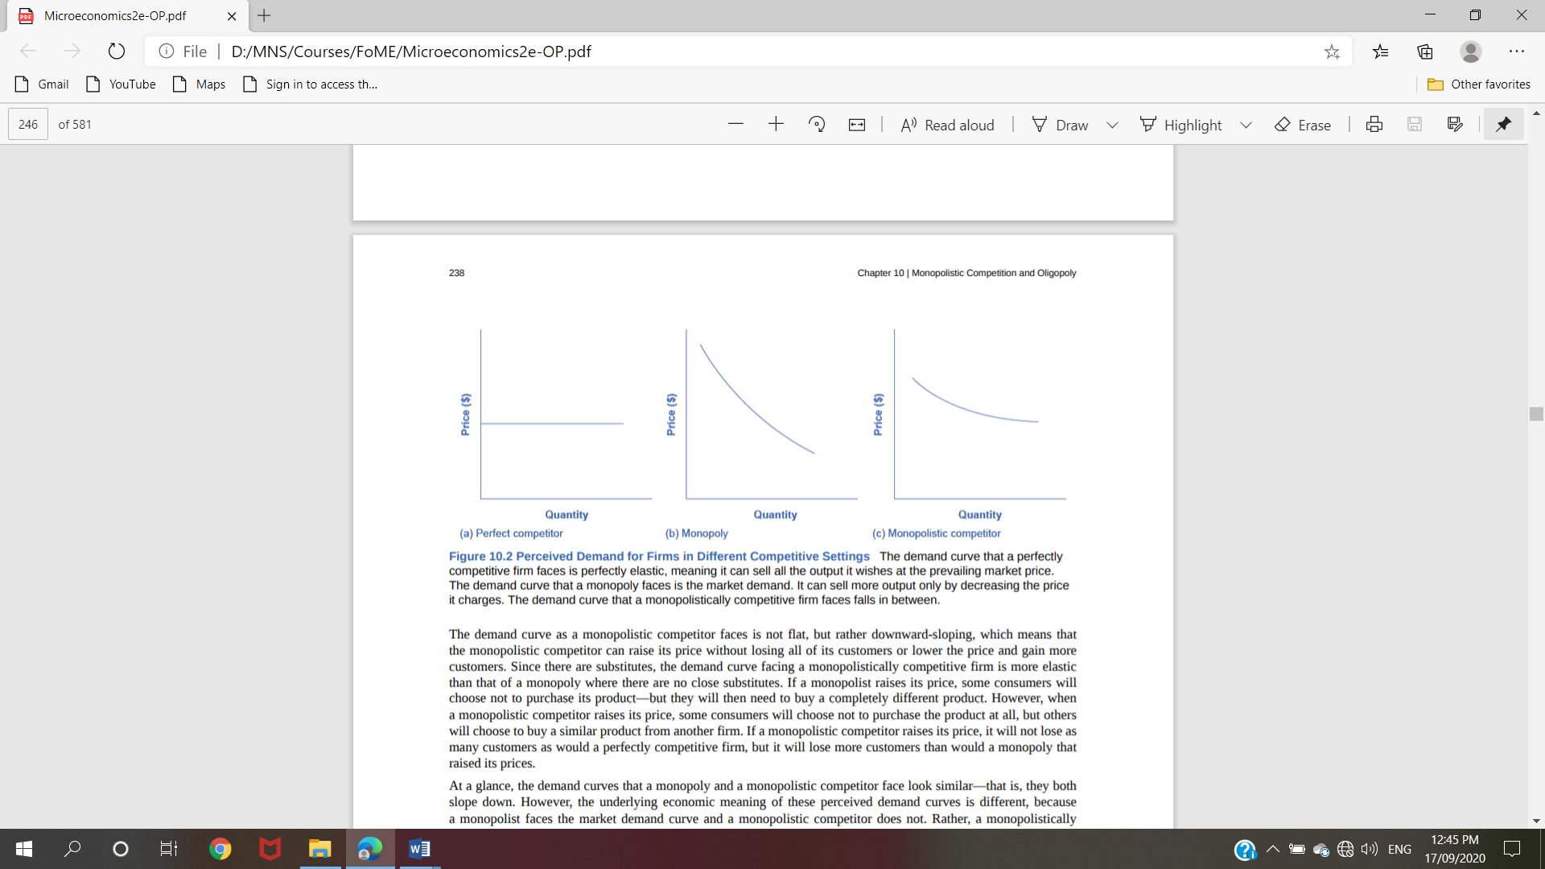

Figure 10.2 Perceived Demand for Firms in Different Competitive Settings The demand curve that a perfectly competitive firm faces is perfectly elastic, meaning it can sell all the output it wishes at the prevailing market price. The demand curve that a monopoly faces is the market demand. It can sell more output only by decreasing the price it charges. The demand curve that a monopolistically competitive firm faces falls in between.
The demand curve as a monopolistic competitor faces is not flat, but rather downward-sloping, which means that the monopolistic competitor can raise its price without losing all of its customers or lower the price and gain more customers. Since there are substitutes, the demand curve facing a monopolistically competitive firm is more elastic than that of a monopoly where there are no close substitutes. If a monopolist raises its price, some consumers will choose not to purchase its product—but they will then need to buy a completely different product. However, when a monopolistic competitor raises its price, some consumers will choose not to purchase the product at all, but others will choose to buy a similar product from another firm. If a monopolistic competitor raises its price, it will not lose as many customers as would a perfectly competitive firm, but it will lose more customers than would a monopoly that raised its prices.
At a glance, the demand curves that a monopoly and a monopolistic competitor face look similar—that is, they both slope down. However, the underlying economic meaning of these perceived demand curves is different, because a monopolist faces the market demand curve and a monopolistic competitor does not. Rather, a monopolistically competitive firm’s demand curve is but one of many firms that make up the “before” market demand curve. Are you following? If so, how would you categorize the market for golf balls? Take a swing, then see the following Clear It Up feature.

How a Monopolistic Competitor Chooses Price and Quantity
The monopolistically competitive firm decides on its profit-maximizing quantity and price in much the same way as a monopolist. A monopolistic competitor, like a monopolist, faces a downward-sloping demand curve, and so it will choose some combination of price and quantity along its perceived demand curve. As an example of a profit-maximizing monopolistic competitor, consider the Authentic Chinese Pizza store, which serves pizza with cheese, sweet and sour sauce, and your choice of vegetables and meats. Although Authentic Chinese Pizza must compete against other pizza businesses and restaurants, it has a differentiated product. The firm’s perceived demand curve is downward sloping, as Figure 10.3 shows and the first two columns of Table 10.1.
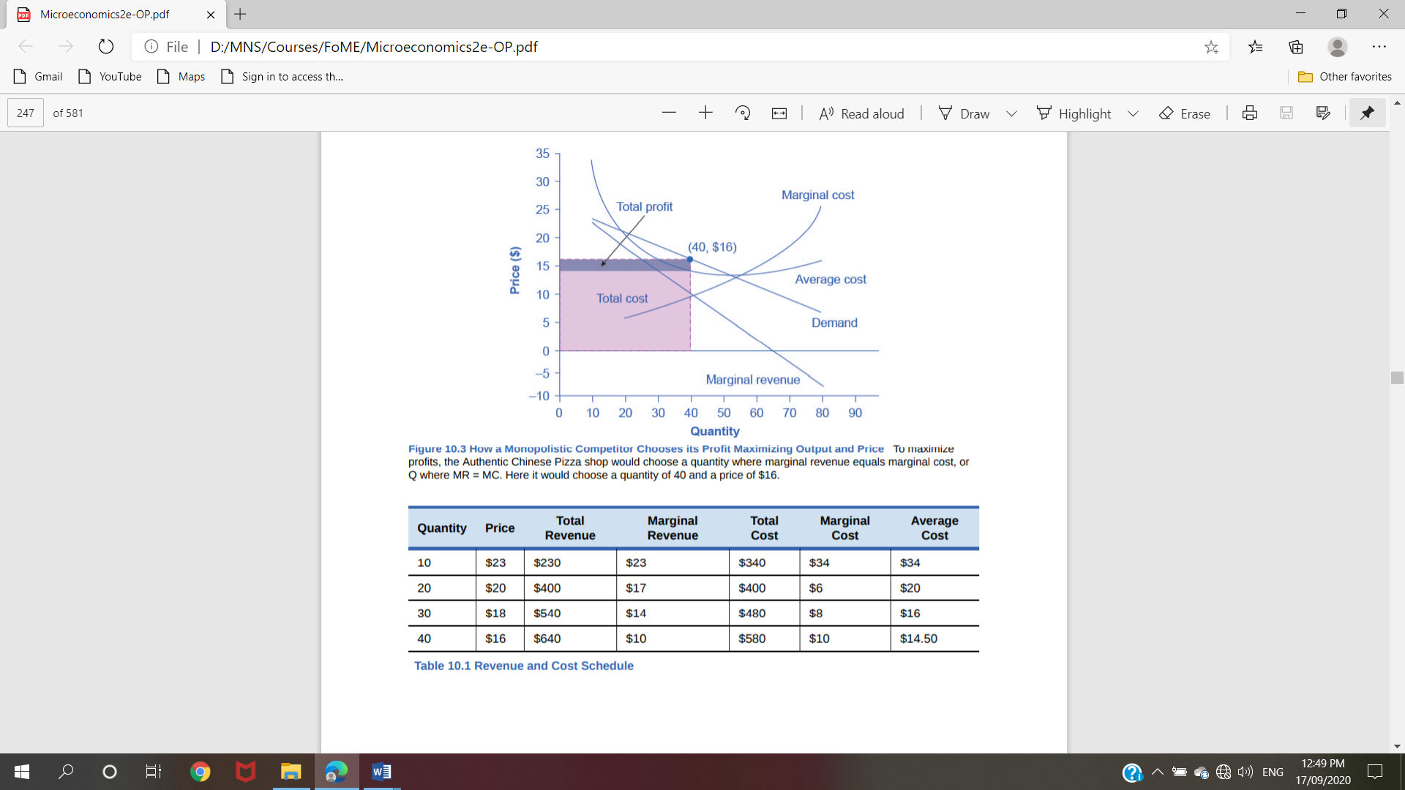

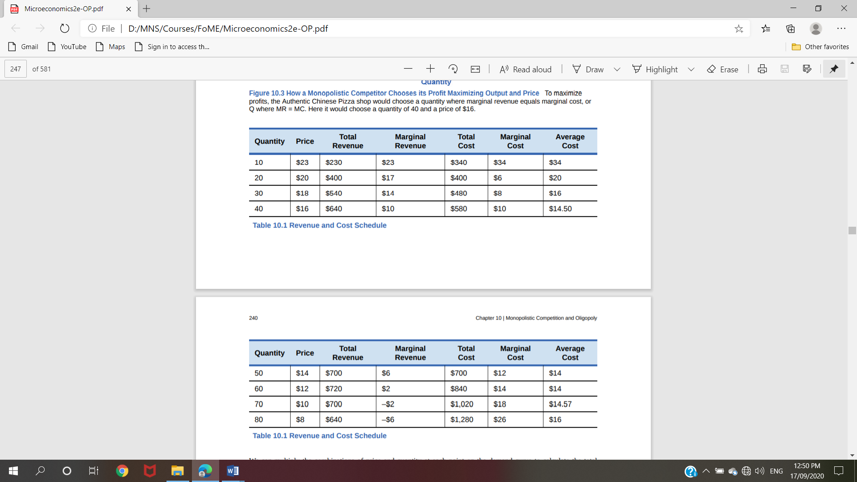

We can multiply the combinations of price and quantity at each point on the demand curve to calculate the total revenue that the firm would receive, which is in the third column of Table 10.1. We calculate marginal revenue, in the fourth column, as the change in total revenue divided by the change in quantity. The final columns of Table 10.1 show total cost, marginal cost, and average cost. As always, we calculate marginal cost by dividing the change in total cost by the change in quantity, while we calculate average cost by dividing total cost by quantity. The following Work It Out feature shows how these firms calculate how much of their products to supply at what price

Although the process by which a monopolistic competitor makes decisions about quantity and price is similar to the way in which a monopolist makes such decisions, two differences are worth remembering. First, although both a monopolist and a monopolistic competitor face downward-sloping demand curves, the monopolist’s perceived demand curve is the market demand curve, while the perceived demand curve for a monopolistic competitor is based on the extent of its product differentiation and how many competitors it faces. Second, a monopolist is surrounded by barriers to entry and need not fear entry, but a monopolistic competitor who earns profits must expect the entry of firms with similar, but differentiated, products.

Monopolistic Competitors and Entry
If one monopolistic competitor earns positive economic profits, other firms will be tempted to enter the market. A gas station with a great location must worry that other gas stations might open across the street or down the road—and perhaps the new gas stations will sell coffee or have a carwash or some other attraction to lure customers. A successful restaurant with a unique barbecue sauce must be concerned that other restaurants will try to copy the sauce or offer their own unique recipes. A laundry detergent with a great reputation for quality must take note that other competitors may seek to build their own reputations.
The entry of other firms into the same general market (like gas, restaurants, or detergent) shifts the demand curve that a monopolistically competitive firm faces. As more firms enter the market, the quantity demanded at a given price for any particular firm will decline, and the firm’s perceived demand curve will shift to the left. As a firm’s perceived demand curve shifts to the left, its marginal revenue curve will shift to the left, too. The shift in marginal revenue will change the profit-maximizing quantity that the firm chooses to produce, since marginal revenue will then equal marginal cost at a lower quantity.
Figure 10.4 (a) shows a situation in which a monopolistic competitor was earning a profit with its original perceived demand curve (D0). The intersection of the marginal revenue curve (MR0) and marginal cost curve (MC) occurs at point S, corresponding to quantity Q0, which is associated on the demand curve at point T with price P0. The combination of price P0 and quantity Q0 lies above the average cost curve, which shows that the firm is earning positive economic profits.
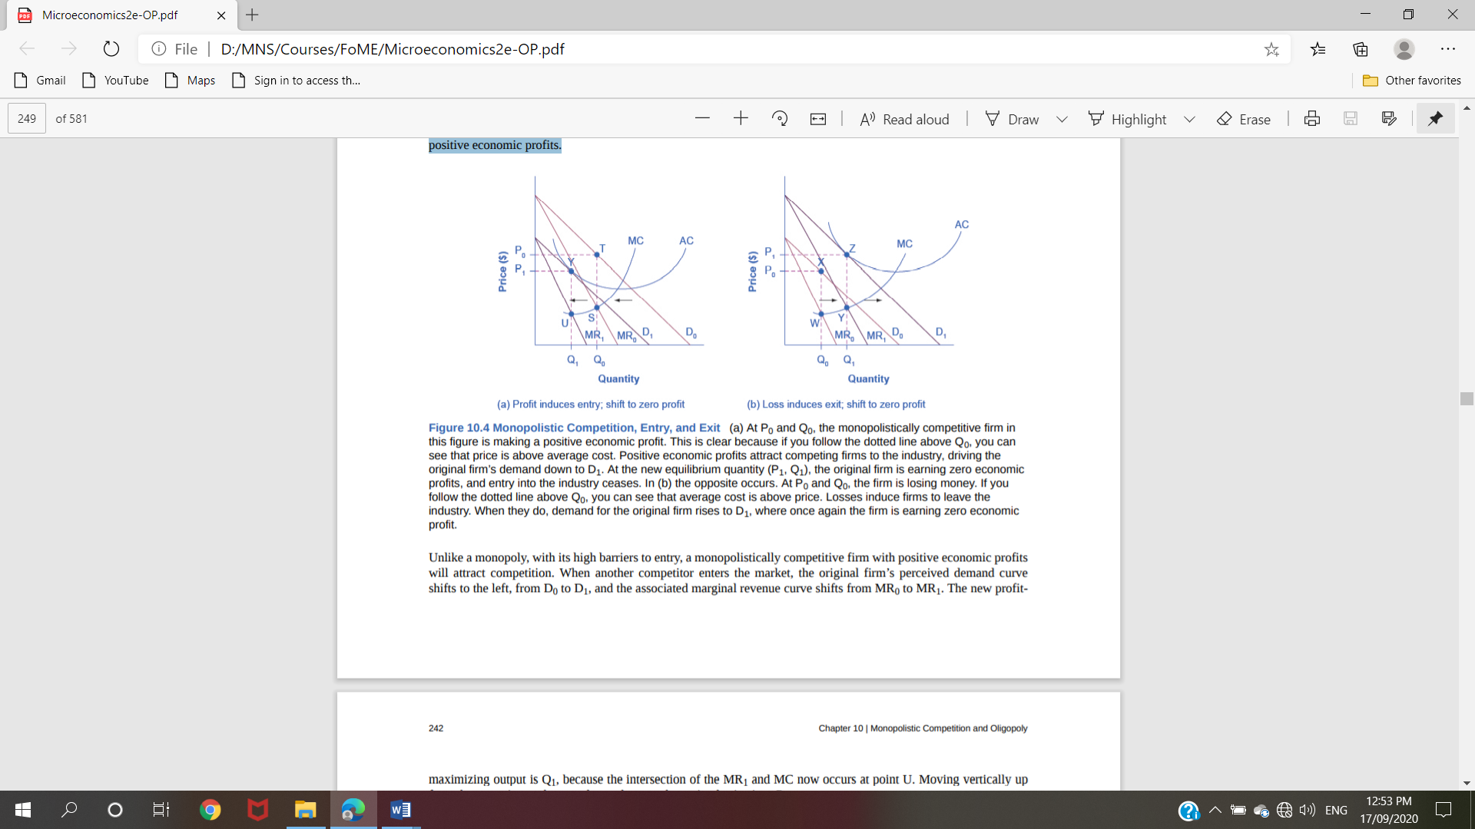

Figure 10.4 Monopolistic Competition, Entry, and Exit (a) At P0 and Q0, the monopolistically competitive firm in this figure is making a positive economic profit. This is clear because if you follow the dotted line above Q0, you can see that price is above average cost. Positive economic profits attract competing firms to the industry, driving the original firm’s demand down to D1. At the new equilibrium quantity (P1, Q1), the original firm is earning zero economic profits, and entry into the industry ceases. In (b) the opposite occurs. At P0 and Q0, the firm is losing money. If you follow the dotted line above Q0, you can see that average cost is above price. Losses induce firms to leave the industry. When they do, demand for the original firm rises to D1, where once again the firm is earning zero economic profit.
Unlike a monopoly, with its high barriers to entry, a monopolistically competitive firm with positive economic profits will attract competition. When another competitor enters the market, the original firm’s perceived demand curve shifts to the left, from D0 to D1 , and the associated marginal revenue curve shifts from MR0 to MR1 . The new profitChapter 10 | Monopolistic Competition and Oligopoly 241 maximizing output is Q1 , because the intersection of the MR1 and MC now occurs at point U. Moving vertically up from that quantity on the new demand curve, the optimal price is at P1 .
As long as the firm is earning positive economic profits, new competitors will continue to enter the market, reducing the original firm’s demand and marginal revenue curves. The long-run equilibrium is in the figure at point Y, where the firm’s perceived demand curve touches the average cost curve. When price is equal to average cost, economic profits are zero. Thus, although a monopolistically competitive firm may earn positive economic profits in the short term, the process of new entry will drive down economic profits to zero in the long run. Remember that zero economic profit is not equivalent to zero accounting profit. A zero economic profit means the firm’s accounting profit is equal to what its resources could earn in their next best use.

Figure 10.4 (b) shows the reverse situation, where a monopolistically competitive firm is originally losing money. The adjustment to long-run equilibrium is analogous to the previous example. The economic losses lead to firms exiting, which will result in increased demand for this particular firm, and consequently lower losses. Firms exit up to the point where there are no more losses in this market, for example when the demand curve touches the average cost curve, as in point Z.
Monopolistic competitors can make an economic profit or loss in the short run, but in the long run, entry and exit will drive these firms toward a zero economic profit outcome. However, the zero economic profit outcome in monopolistic competition looks different from the zero economic profit outcome in perfect competition in several ways relating both to efficiency and to variety in the market.

Monopolistic Competition and Efficiency
The long-term result of entry and exit in a perfectly competitive market is that all firms end up selling at the price level determined by the lowest point on the average cost curve. This outcome is why perfect competition displays productive efficiency: goods are produced at the lowest possible average cost. However, in monopolistic competition, the end result of entry and exit is that firms end up with a price that lies on the downward-sloping portion of the average cost curve, not at the very bottom of the AC curve. Thus, monopolistic competition will not be productively efficient.
In a perfectly competitive market, each firm produces at a quantity where price is set equal to marginal cost, both in the short and long run. This outcome is why perfect competition displays allocative efficiency: the social benefits of additional production, as measured by the marginal benefit, which is the same as the price, equal the marginal costs to society of that production. In a monopolistically competitive market, the rule for maximizing profit is to set MR = MC—and price is higher than marginal revenue, not equal to it because the demand curve is downward sloping. When P > MC, which is the outcome in a monopolistically competitive market, the benefits to society of providing additional quantity, as measured by the price that people are willing to pay, exceed the marginal costs to society of producing those units. A monopolistically competitive firm does not produce more, which means that society loses the net benefit of those extra units. This is the same argument we made about monopoly, but in this case the allocative inefficiency will be smaller. Thus, a monopolistically competitive industry will produce a lower quantity of a good and charge a higher price for it than would a perfectly competitive industry. See the following Clear It Up feature for more detail on the impact of demand shifts.

A monopolistically competitive industry does not display productive or allocative efficiency in either the short run, when firms are making economic profits and losses, nor in the long run, when firms are earning zero profits.

The Benefits of Variety and Product Differentiation
Even though monopolistic competition does not provide productive efficiency or allocative efficiency, it does have benefits of its own. Product differentiation is based on variety and innovation. Most people would prefer to live in an economy with many kinds of clothes, foods, and car styles; not in a world of perfect competition where everyone will always wear blue jeans and white shirts, eat only spaghetti with plain red sauce, and drive an identical model of car. Most people would prefer to live in an economy where firms are struggling to figure out ways of attracting customers by methods like friendlier service, free delivery, guarantees of quality, variations on existing products, and a better shopping experience.
Economists have struggled, with only partial success, to address the question of whether a market-oriented economy produces the optimal amount of variety. Critics of market-oriented economies argue that society does not really need dozens of different athletic shoes or breakfast cereals or automobiles. They argue that much of the cost of creating such a high degree of product differentiation, and then of advertising and marketing this differentiation, is socially wasteful—that is, most people would be just as happy with a smaller range of differentiated products produced and sold at a lower price. Defenders of a market-oriented economy respond that if people do not want to buy differentiated products or highly advertised brand names, no one is forcing them to do so. Moreover, they argue that consumers benefit substantially when firms seek short-term profits by providing differentiated products. This controversy may never be fully resolved, in part because deciding on the optimal amount of variety is very difficult, and in part because the two sides often place different values on what variety means for consumers. Read the following Clear It Up feature for a discussion on the role that advertising plays in monopolistic competition.

Oligopoly

Many purchases that individuals make at the retail level are produced in markets that are neither perfectly competitive, monopolies, nor monopolistically competitive. Rather, they are oligopolies. Oligopoly arises when a small number of large firms have all or most of the sales in an industry. Examples of oligopoly abound and include the auto industry, cable television, and commercial air travel. Oligopolistic firms are like cats in a bag. They can either scratch each other to pieces or cuddle up and get comfortable with one another. If oligopolists compete hard, they may end up acting very much like perfect competitors, driving down costs and leading to zero profits for all. If oligopolists collude with each other, they may effectively act like a monopoly and succeed in pushing up prices and earning consistently high levels of profit. We typically characterize oligopolies by mutual interdependence where various decisions such as output, price, and advertising depend on other firm(s)' decisions. Analyzing the choices of oligopolistic firms about pricing and quantity produced involves considering the pros and cons of competition versus collusion at a given point in time

Why Do Oligopolies Exist?
A combination of the barriers to entry that create monopolies and the product differentiation that characterizes monopolistic competition can create the setting for an oligopoly. For example, when a government grants a patent for an invention to one firm, it may create a monopoly. When the government grants patents to, for example, three different pharmaceutical companies that each has its own drug for reducing high blood pressure, those three firms may become an oligopoly.
Similarly, a natural monopoly will arise when the quantity demanded in a market is only large enough for a single firm to operate at the minimum of the long-run average cost curve. In such a setting, the market has room for only one firm, because no smaller firm can operate at a low enough average cost to compete, and no larger firm could sell what it produced given the quantity demanded in the market.
Quantity demanded in the market may also be two or three times the quantity needed to produce at the minimum of the average cost curve—which means that the market would have room for only two or three oligopoly firms (and they need not produce differentiated products). Again, smaller firms would have higher average costs and be unable to compete, while additional large firms would produce such a high quantity that they would not be able to sell it at a profitable price. This combination of economies of scale and market demand creates the barrier to entry, which led to the Boeing-Airbus oligopoly (also called a duopoly) for large passenger aircraft.
The product differentiation at the heart of monopolistic competition can also play a role in creating oligopoly. For example, firms may need to reach a certain minimum size before they are able to spend enough on advertising and marketing to create a recognizable brand name. The problem in competing with, say, Coca-Cola or Pepsi is not that producing fizzy drinks is technologically difficult, but rather that creating a brand name and marketing effort to equal Coke or Pepsi is an enormous task

Collusion or Competition?
When oligopoly firms in a certain market decide what quantity to produce and what price to charge, they face a temptation to act as if they were a monopoly. By acting together, oligopolistic firms can hold down industry output, charge a higher price, and divide the profit among themselves. When firms act together in this way to reduce output and keep prices high, it is called collusion. A group of firms that have a formal agreement to collude to produce the monopoly output and sell at the monopoly price is called a cartel. See the following Clear It Up feature for a more in-depth analysis of the difference between the two.

Economists have understood for a long time the desire of businesses to avoid competing so that they can instead raise the prices that they charge and earn higher profits. Adam Smith wrote in Wealth of Nations in 1776: “People of the same trade seldom meet together, even for merriment and diversion, but the conversation ends in a conspiracy against the public, or in some contrivance to raise prices.”
Even when oligopolists recognize that they would benefit as a group by acting like a monopoly, each individual oligopoly faces a private temptation to produce just a slightly higher quantity and earn slightly higher profit—while still counting on the other oligopolists to hold down their production and keep prices high. If at least some oligopolists give in to this temptation and start producing more, then the market price will fall. A small handful of oligopoly firms may end up competing so fiercely that they all find themselves earning zero economic profits—as if they were perfect competitors.

The Prisoner’s Dilemma
Because of the complexity of oligopoly, which is the result of mutual interdependence among firms, there is no single, generally-accepted theory of how oligopolies behave, in the same way that we have theories for all the other market structures. Instead, economists use game theory, a branch of mathematics that analyzes situations in which players must make decisions and then receive payoffs based on what other players decide to do. Game theory has found widespread applications in the social sciences, as well as in business, law, and military strategy. The prisoner’s dilemma is a scenario in which the gains from cooperation are larger than the rewards from pursuing self-interest. It applies well to oligopoly. The story behind the prisoner’s dilemma goes like this:

Two co-conspiratorial criminals are arrested. When they are taken to the police station, they refuse to say anything and are put in separate interrogation rooms. Eventually, a police officer enters the room where Prisoner A is being held and says: “You know what? Your partner in the other room is confessing. Your partner is going to get a light prison sentence of just one year, and because you’re remaining silent, the judge is going to stick you with eight years in prison. Why don’t you get smart? If you confess, too, we’ll cut your jail time down to five years, and your partner will get five years, also.” Over in the next room, another police officer is giving exactly the same speech to Prisoner B. What the police officers do not say is that if both prisoners remain silent, the evidence against them is not especially strong, and the prisoners will end up with only two years in jail each.

The game theory situation facing the two prisoners is in Table 10.2. To understand the dilemma, first consider the choices from Prisoner A’s point of view. If A believes that B will confess, then A should confess, too, so as to not get stuck with the eight years in prison. However, if A believes that B will not confess, then A will be tempted to act selfishly and confess, so as to serve only one year. The key point is that A has an incentive to confess regardless of what choice B makes! B faces the same set of choices, and thus will have an incentive to confess regardless of what choice A makes. To confess is called the dominant strategy. It is the strategy an individual (or firm) will pursue regardless of the other individual’s (or firm’s) decision. The result is that if prisoners pursue their own self-interest, both are likely to confess, and end up doing a total of 10 years of jail time between them.
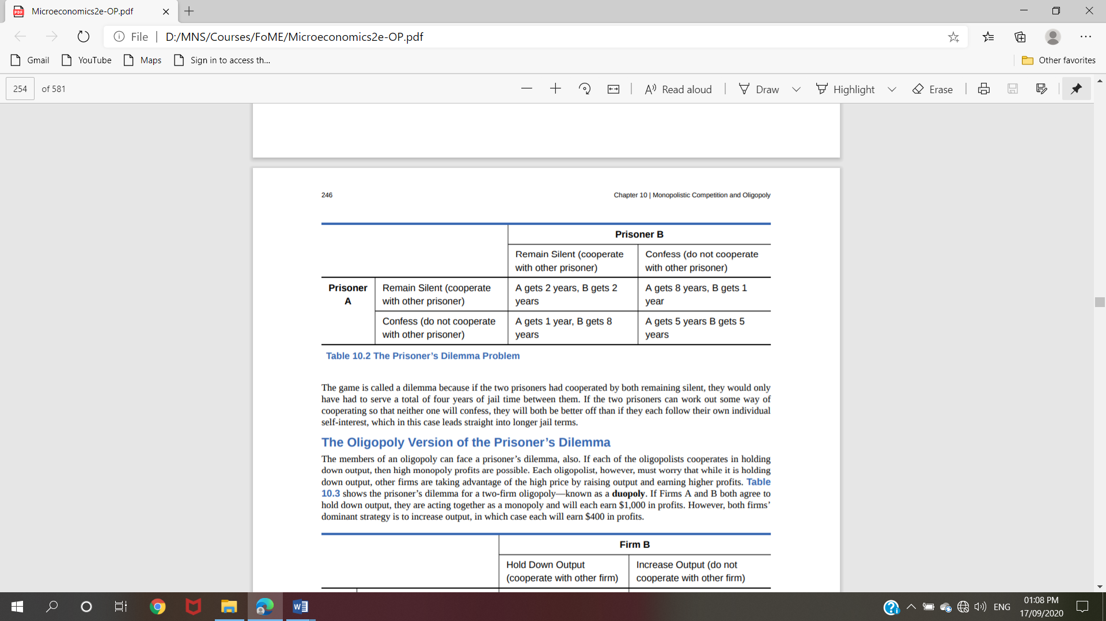
The game is called a dilemma because if the two prisoners had cooperated by both remaining silent, they would only have had to serve a total of four years of jail time between them. If the two prisoners can work out some way of cooperating so that neither one will confess, they will both be better off than if they each follow their own individual self-interest, which in this case leads straight into longer jail terms.

The Oligopoly Version of the Prisoner’s Dilemma
The members of an oligopoly can face a prisoner’s dilemma, also. If each of the oligopolists cooperates in holding down output, then high monopoly profits are possible. Each oligopolist, however, must worry that while it is holding down output, other firms are taking advantage of the high price by raising output and earning higher profits. Table 10.3 shows the prisoner’s dilemma for a two-firm oligopoly—known as a duopoly. If Firms A and B both agree to hold down output, they are acting together as a monopoly and will each earn $1,000 in profits. However, both firms’ dominant strategy is to increase output, in which case each will earn $400 in profits.
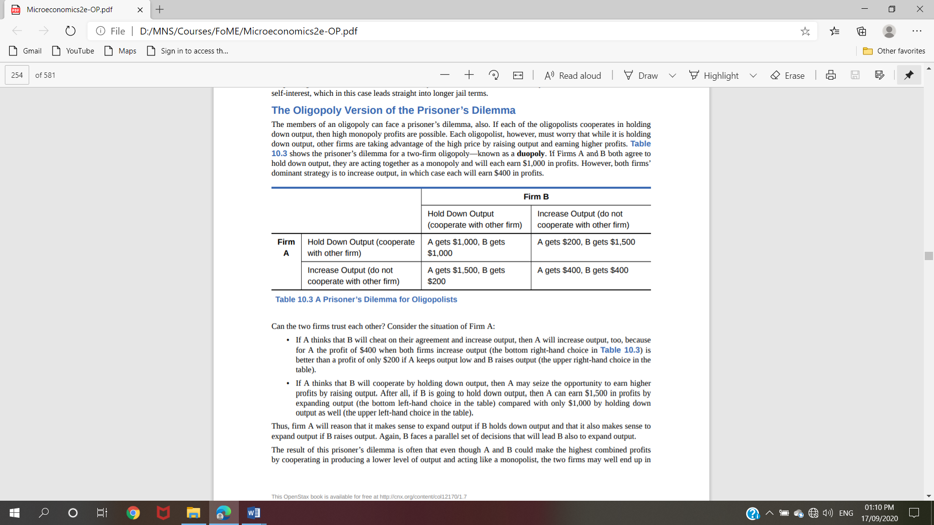
Can the two firms trust each other? Consider the situation of Firm A:
• If A thinks that B will cheat on their agreement and increase output, then A will increase output, too, because for A the profit of $400 when both firms increase output (the bottom right-hand choice in Table 10.3) is better than a profit of only $200 if A keeps output low and B raises output (the upper right-hand choice in the table).
• If A thinks that B will cooperate by holding down output, then A may seize the opportunity to earn higher profits by raising output. After all, if B is going to hold down output, then A can earn $1,500 in profits by expanding output (the bottom left-hand choice in the table) compared with only $1,000 by holding down output as well (the upper left-hand choice in the table).
Thus, firm A will reason that it makes sense to expand output if B holds down output and that it also makes sense to expand output if B raises output. Again, B faces a parallel set of decisions that will lead B also to expand output. The result of this prisoner’s dilemma is often that even though A and B could make the highest combined profits by cooperating in producing a lower level of output and acting like a monopolist, the two firms may well end up in a situation where they each increase output and earn only $400 each in profits. The following Clear It Up feature discusses one cartel scandal in particular.
How to Enforce Cooperation
How can parties who find themselves in a prisoner’s dilemma situation avoid the undesired outcome and cooperate with each other? The way out of a prisoner’s dilemma is to find a way to penalize those who do not cooperate. Perhaps the easiest approach for colluding oligopolists, as you might imagine, would be to sign a contract with each other that they will hold output low and keep prices high. If a group of U.S. companies signed such a contract, however, it would be illegal. Certain international organizations, like the nations that are members of the Organization of Petroleum Exporting Countries (OPEC), have signed international agreements to act like a monopoly, hold down output, and keep prices high so that all of the countries can make high profits from oil exports. Such agreements, however, because they fall in a gray area of international law, are not legally enforceable. If Nigeria, for example, decides to start cutting prices and selling more oil, Saudi Arabia cannot sue Nigeria in court and force it to stop.
Because oligopolists cannot sign a legally enforceable contract to act like a monopoly, the firms may instead keep close tabs on what other firms are producing and charging. Alternatively, oligopolists may choose to act in a way that generates pressure on each firm to stick to its agreed quantity of output. One example of the pressure these firms can exert on one another is the kinked demand curve, in which competing oligopoly firms commit to match price cuts, but not price increases. Figure 10.5 shows this situation. Say that an oligopoly airline has agreed with the rest of a cartel to provide a quantity of 10,000 seats on the New York to Los Angeles route, at a price of $500. This choice defines the kink in the firm’s perceived demand curve. The reason that the firm faces a kink in its demand curve is because of how the other oligopolists react to changes in the firm’s price. If the oligopoly decides to produce more and cut its price, the other members of the cartel will immediately match any price cuts—and therefore, a lower price brings very little increase in quantity sold. If one firm cuts its price to $300, it will be able to sell only 11,000 seats. However, if the airline seeks to raise prices, the other oligopolists will not raise their prices, and so the firm that raised prices will lose a considerable share of sales. For example, if the firm raises its price to $550, its sales drop to 5,000 seats sold. Thus, if oligopolists always match price cuts by other firms in the cartel, but do not match price increases, then none of the oligopolists will have a strong incentive to change prices, since the potential gains are minimal. This strategy can work like a silent form of cooperation, in which the cartel successfully manages to hold down output, increase price, and share a monopoly level of profits even without any legally enforceable agreement.
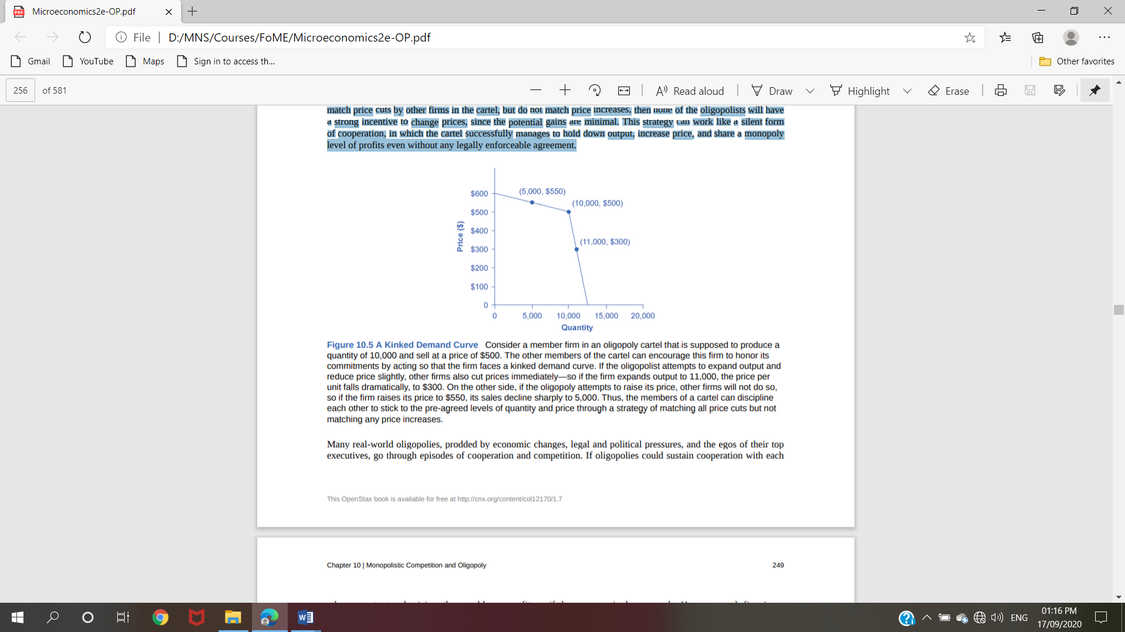
Figure 10.5 A Kinked Demand
Curve Consider a member firm in an oligopoly cartel that is supposed to produce a quantity of 10,000 and sell at a price of $500. The other members of the cartel can encourage this firm to honor its commitments by acting so that the firm faces a kinked demand curve. If the oligopolistic attempts to expand output and reduce price slightly, other firms also cut prices immediately—so if the firm expands output to 11,000, the price per unit falls dramatically, to $300. On the other side, if the oligopoly attempts to raise its price, other firms will not do so, so if the firm raises its price to $550, its sales decline sharply to 5,000. Thus, the members of a cartel can discipline each other to stick to the pre-agreed levels of quantity and price through a strategy of matching all price cuts but not matching any price increases.
Many real-world oligopolies, prodded by economic changes, legal and political pressures, and the egos of their top executives, go through episodes of cooperation and competition. If oligopolies could sustain cooperation with each other on output and pricing, they could earn profits as if they were a single monopoly. However, each firm in an oligopoly has an incentive to produce more and grab a bigger share of the overall market; when firms start behaving in this way, the market outcome in terms of prices and quantity can be similar to that of a highly competitive market

